
Faculty of Education, Languages, Psychology and Music

Name (According to NRIC/Passport): | SEGi Student ID:
- Tai Zheng Yu | SCSJ2300548
Programme: BACHELOR OF SCIENCE (HONS) COMPUTER SCIENCE (CYBER SECURITY)
Course Name: 5COM2003 | Course Code: ARTIFICIAL INTELLIGENCE
Name of Course Lecturer: Uzair Izzuddin Bin Mohd Zain
Date of Submission: 17/ 06/2025
Assignment Title / Topic: Developing Decision-Making Agents Using AI Architectures for Maze Navigation

By submitting this assignment:
I confirm that this assignment is fully my own work.
I have read and understood the University/college regulations on plagiarism and cheating as stated in the Student Handbook. I declare that the assignment submitted does not breach those regulation.

Table of Contents
Tables of Figures 4
Introduction 5
Project Overview 5
Maze Environment Implementation 6
Task 1: Finite State Machine (FSM) Controller 7
Overview of Finite State Machine Architecture 7
FSM State Definition 7
FSM State Transition Logic 8
FSM Action Execution 8
FSM Behaviour Analysis 9
Task 2: Behaviour Tree Controller 10
Overview of Behaviour Tree Architecture 10
Behaviour Tree Structure 10
Node Evaluation Process 11
Action Node Implementation 12
Behaviour Tree Analysis 12
Task 3: Utility-Based System 13
Overview of Utility-Based Architecture 13
Utility Function Design 13
Goal Score Evaluation 14
Visited Penalty Evaluation 15
Safety Score Evaluation 15
Action Selection Process 16
Utility-Based Behavior Analysis 17
Task 4: Simulate Scenario Environment 18
Overview of the Simulation Environment 18
Maze Environment Class 19
Locating the Start and Goal Positions 19
Movement Validation 20
Neighbor detection 20
Goal Distance Calculation 21
Task 5: Agent Behaviour 22
Agent Architecture 22
Controller-Based Decision Making 22
Movement Execution 23
Goal Detection 23
Navigation Loop 23
Obstacle Avoidance Behavior 24
Adaptability Analysis 24
The Final Output Result 25
Comparative Analysis 27
Conclusion 28
References 28

Tables of Figures
Figure 1 Maze Structure Used for the Navigation Environment 6
Figure 2 Manhattan Distance Function for Goal Distance Calculation 6
Figure 3 FSM Controller Initial State Definition 7
Figure 4 FSM State Transition Logic Implementation 8
Figure 5FSM Goal-Reaching Action Implementation 8
Figure 6 FSM Obstacle Avoidance Logic 9
Figure 7 Behaviour Tree Decision Logic Structure 11
Figure 8 Goal Detection Condition in Behaviour Tree 11
Figure 9 Obstacle Detection Condition in Behaviour Tree 11
Figure 10 Move-to-Goal Action Node Implementation 12
Figure 11 Obstacle Avoidance Action Node Implementation 12
Figure 12 Utility Function Design for Action Evaluation 14
Figure 13 Goal Score Calculation within the Utility Function 14
Figure 14 Visited Location Penalty Calculation 15
Figure 15 Safety Score Calculation Based on Available Neighbours 15
Figure 16 Utility-Based Action Selection Process 16
Figure 17 Maze Structure Used for the Navigation Environment 18
Figure 18 MazeEnvironment Class Implementation 19
Figure 19 Start and Goal Position Detection Function 19
Figure 20 Movement Validation Function 20
Figure 21 Neighbour Detection Function 20
Figure 22 Goal Distance Calculation Using Manhattan Distance 21
Figure 23 Agent Class Implementation 22
Figure 24 Controller-Based Decision-Making Mechanism 22
Figure 25 Agent Movement Execution Process 23
Figure 26 Goal Detection Function 23
Figure 27 Main Navigation Loop Execution 23
Figure 28 FSM Agent Navigating Through the Maze Environment 25
Figure 29 Behaviour Tree Agent Navigating Through the Maze Environment 25
Figure 30 Utility-Based Agent Navigating Through the Maze Environment 26
Figure 31 Performance Comparison of FSM, Behaviour Tree, and Utility-Based System Controllers 26

Introduction
Artificial Intelligence (AI) plays a significant role in enabling autonomous systems to make decisions and perform tasks without direct human intervention. Different AI architectures employ different approaches to decision-making, resulting in varying levels of adaptability, efficiency and complexity. In autonomous navigation systems, intelligent agents must continuously analyze their surroundings and determine the most suitable actions to achieve specific objectives.
The purpose of this project is to design and implement three different AI decision-making architectures which is Finite State Machine (FSM), Behaviour Tree (BT) and Utility-Based System (UBS). Each architecture is used to control an agent navigating through a maze environment. Moreover, the agent must move form a predefined starting position to a goal location while avoiding obstacles represented by maze walls. Hence, the project aims to evaluate how different AI architectures influence agent behaviour and navigation performance. The performance is assessed through multiple simulation runs using metrics such as success rate, average number of steps taken and obstacle avoidance effectiveness.

Project Overview
The project consists of a simulated maze environment and an autonomous agent controlled by different AI architectures. The maze is represented as a two-dimensional grid where specific symbols indicate the starting location, goal location and obstacles.
The implemented AI architectures include:
- Finite State Machine (FSM)
- Behaviour Tree (BT)
- Utility-Based System (UBS)
Each controller independently guides the agent’s navigation process. Demonstration files are used to visualize the movement of each controller while a separate simulation file performs 1000 simulation runs to evaluate overall performance.

Maze Environment Implementation
The maze environment forms the foundation of the project and it provides the space in which the intelligent agent operates and supplies information required for decision-making. Furthermore, the maze is represented using a Python list containing rows of characters.
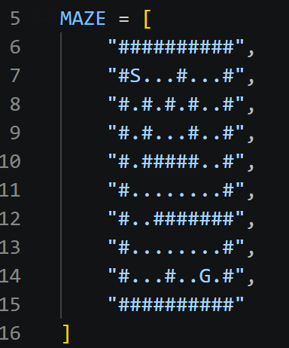
Figure 1 Maze Structure Used for the Navigation Environment
In the maze, the symbol S represents the starting position and the symbol G represents the goal position as well as the symbol # represents walls or obstacles. Moreover, the empty spaces indicate valid paths through which the agent may move.
The “MazeEnvironment” class manages the environment and it identifies the locations of the starting point and goal, validates movement requests, retrieves neighboring cells and calculates the distance between the agent and the goal. For example, the one important function is the distance calculation which is showing below.
Figure 2 Manhattan Distance Function for Goal Distance Calculation
This function uses Manhattan Distance to estimate the distance between the current agent position and the goal location. The calculated value is later used by all three controllers to assist navigation decisions.

Task 1: Finite State Machine (FSM) Controller

Overview of Finite State Machine Architecture
The Finite State Machine (FSM) architecture is one of the most fundamental AI decision-making approaches. In an FSM, the behaviour of an agent is divided into a number of predefined states where each state represents a specific behaviour or objective. Moreover, the agent can only exist in one state at a given time and transitions occur when environmental conditions satisfy predefined rules.
For this project, the FSM architecture was selected because it provides a clear and structured decision-making process. Furthermore, the agent’s behaviour can be easily tracked and explained through state transitions which making it suitable for demonstrating autonomous navigation behaviour in a maze environment.
The FSM implemented in this project contains three behavioral states:
- Exploring
- Avoiding Obstacle
- Reaching Goal
Each state performs a specific role during navigation. By separating behaviours into individual states, the controller can react differently depending on the surrounding environment.

FSM State Definition
The FSM controller is initialized with the following default state:
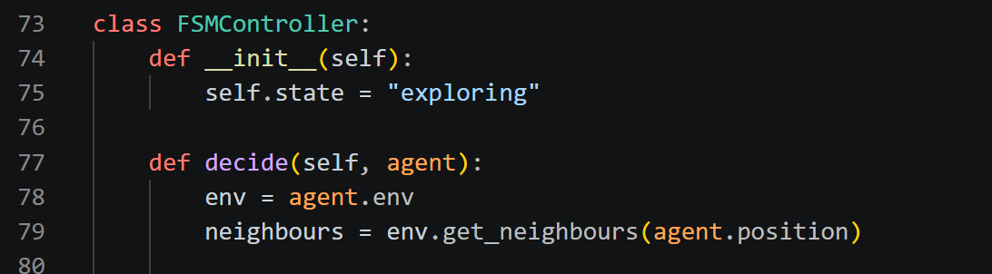
Figure 3 FSM Controller Initial State Definition
At the beginning of navigation, the agent enters the Exploring state. This state represents normal maze traversal where the agent searches for valid paths while attempting to move closer to the goal. Hence, the use of an initial state ensures that the agent has a defined starting behaviour immediately after being placed into the environment.

FSM State Transition Logic
The most important component of an FSM is the transition system. The transition system determines when the agent should change its behaviour. The transition logic is implemented as following below.
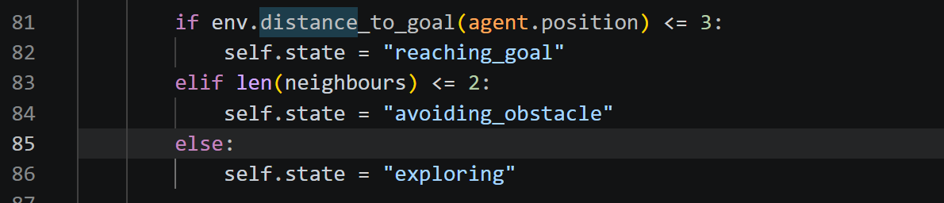
Figure 4 FSM State Transition Logic Implementation
The first condition checks whether the goal is located within a short distance of the current position. When this occurs, the FSM transitions into the Reaching Goal state and this allows the agent to priorities direct movement toward the destination. Moreover, the second condition evaluates the number of available neighboring cells. When only a few movement options exist, it indicates that obstacles are restricting movement therefore the FSM transitions into the Avoiding Obstacle State. If neither condition is satisfied, the FSM remains in the Exploring state. Hence, this transition structure ensures that the agent continuously adapts its behaviour according to environment conditions rather than following a fixed movement pattern.

FSM Action Execution
Once a state has been selected, the controller executes the action associated with that state.
For example:
Figure 5FSM Goal-Reaching Action Implementation
In this state, the agent evaluates all neighbouring positions and selects the one that minimizes the distance to the goal. Hence, this behaviour increases navigation efficiency because every movement directly contributes toward reaching the destination.
For obstacle avoidance:
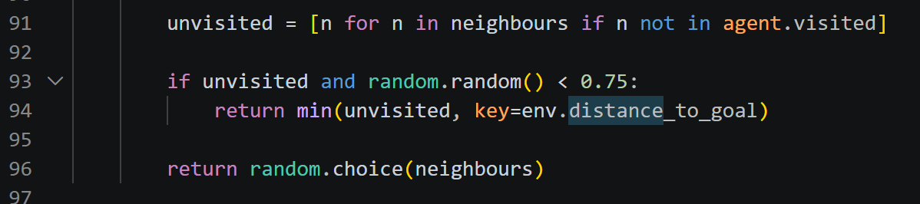
Figure 6 FSM Obstacle Avoidance Logic
The controller prioritizes unisited locations and this reduces repetitive movement and helps the agent avoid becoming trapped in loops.

FSM Behaviour Analysis
The FSM effectively guides the agent by dividing navigation into clearly defined behavioural modes. In additional, the architecture demonstrates adaptive navigation because the agent automatically changes states when environmental conditions change.
The FSM successfully satisfies the project requirements by:
- Defining multiple behavioural states
- Implementing state transitions
- Associating actions with each state
- Guiding navigation toward the goal
- Supporting obstacle avoidance.
Although the FSM is relatively simple, it provides a strong foundation for autonomous navigation and demonstrates how state-driven decision-making can influence agent behaviour.

Task 2: Behaviour Tree Controller

Overview of Behaviour Tree Architecture
Behaviour Tree are hierarchical decision-making structures that organize behaviours into modular components. Unlike FSMs which rely on state transitions, Behaviour Trees evaluate conditions and execute actions according to a tree-like structure. Moreover, the Behaviour Trees are Widely used in robotics and modern game AI because they provide greater flexibility and scalability than traditional FSM architectures.
The Behaviour Tree implemented in this project contains:
- Condition Nodes
- Decision Nodes
- Action Nodes
These components work together to determine the most appropriate action at every navigation step.

Behaviour Tree Structure
the Behaviour Tree controller organizes the agent’s decision-making process into a hierarchy of conditions and actions. Instead of relying on predefined states like the Finite State Machine, the Behaviour Tree evaluates environmental conditions in a specific order and executes the corresponding action when a condition is satisfied. This hierarchical approach allows the controller to prioritize important behaviours while maintaining a clear and modular structure. For example, the decision-making process begins by checking whether the agent is close to the goal location. This condition is assigned the highest priority because reaching the goal is the primary objective of the navigation task. If the goal is detected within the specified distance threshold, the controller immediately executes the action that moves the agent towards the destination. This ensures that the agent focuses on completing the task as efficiently as possible whenever an opportunity to reach the goal is available.
If the goal is not nearby, the controller then evaluates whether the agent is approaching a constrained area or obstacle. This is achieved by analyzing the number of valid neighboring positions surrounding the agent. When movement options become limited, the controller activates the obstacle avoidance behaviour. The purpose of this behaviour is to prevent the agent from becoming trapped and to encourage movement towards safer positions with more available paths.
When neither the goal detection condition nor the obstacle detection condition is satisfied, the controller enters the exploration behaviour. Exploration serves as the default action and allows the agent to continue searching the maze for possible routes towards the destination. During exploration, the controller prioritizes unvisited locations whenever possible to improve coverage of the environment and reduce repetitive movements. The hierarchical evaluation order ensures that the most important behaviours are considered first. Goal-seeking behaviour is prioritized because it directly contributes to successful task completion, obstacle avoidance is prioritized second to maintain safe navigation and exploration is performed when no immediate objectives require attentions. This structure enables the Behaviour Tree to produce organized, adaptive and efficient decision-making throughout the navigation process.

Node Evaluation Process
The decision logic is implemented as following below.
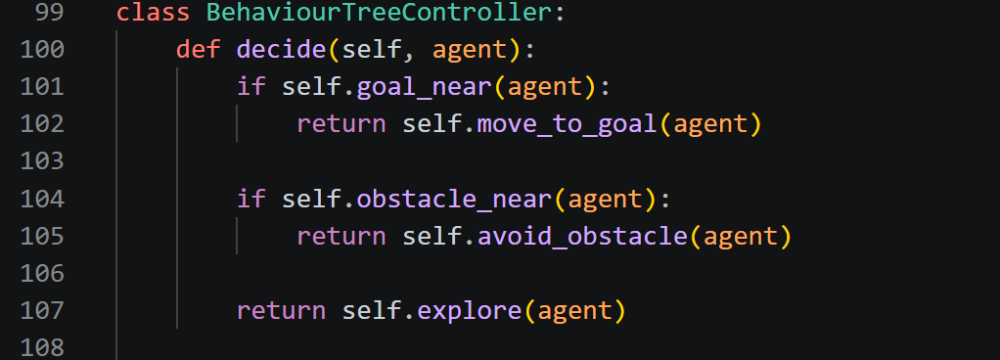
Figure 7 Behaviour Tree Decision Logic Structure
The controller evaluates nodes from top to bottom.
The first condition checks whether the goal is within a predefined distance threshold.
Figure 8 Goal Detection Condition in Behaviour Tree
If this condition returns True, the tree immediately executes the Move To Goal action.
If the goal is not nearby, the controller evaluates the obstacle detection condition.
Figure 9 Obstacle Detection Condition in Behaviour Tree
This determines whether the agent is located in a constrained area.

Action Node Implementation
The Move To Goal action is implementation as:
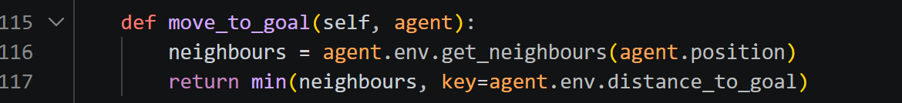
Figure 10 Move-to-Goal Action Node Implementation
This action selects the neighboring position that produces the smallest distance to the goal.
The Avoid Obstacle action prioritizes safer and unvisited positions:
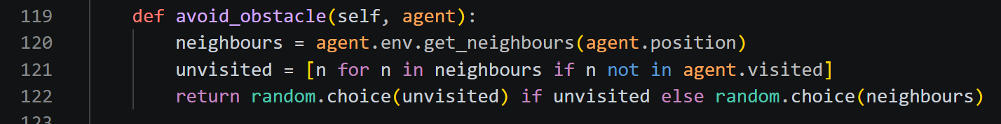
Figure 11 Obstacle Avoidance Action Node Implementation
This reduces the probability of repeated movements and improves navigation efficiency. Hence, the explore action allows the agent to search new paths when neither the goal nor obstacles require immediate attention.

Behaviour Tree Analysis
The behaviour Tree architecture provide a more organized and flexible decision-making approach than the Finite State Machine. Instead of relying on fixed sates and transitions, it divides behaviours into independent nodes that are evaluated hierarchically. This allows the agent to assess different conditions and select the most suitable action based on the current environment which making the system easier to understand and maintain.
A key strength of the Behavior Tree is its modular design and behaviors such as goal detection, obstacle avoidance and exploration are implemented as separate nodes with specific responsibilities. This improves code readability and makes it easier to add new behaviours without significantly changing the overall structure. Moreover, the hierarchical evaluation process ensures that important objectives are prioritized. In this implementation, the controller first checks whether the goal is nearby and moves towards it when detected. If the goal is not within range, obstacle avoidance is evaluated while exploration is only performed when no higher-priority behaviour is required. This enables the agent to make logical and efficient decisions while navigating the maze.
Furthermore, the behaviour Tree also demonstrates adaptability by continuously re-evaluating conditions and switching behavior when necessary. This allows the agent to respond effectively to changes in the environment without relying on fixed state transitions. Therefore, the behaviour Tree successfully guides the agent through the mase by providing clear decision-making, effective behavior prioritization and adaptability. These features make it a strong AI architecture for autonomous maze navigation.

Task 3: Utility-Based System

Overview of Utility-Based Architecture
The Utility-Based System is an advanced decision-making architecture that selects action based on numerical utility values. Unlike Finite State Machines which rely on predefined states or Behavior Trees which rely on condition-action structures, a Utility-Based System evaluates all available actions and choose the option that provides the greatest overall benefit.
The fundamental principle behind this architecture is that every possible action has both advantages and disadvantages. Instead of following a fixed set of rules, the controller calculates a utility score for each available action and selects the action with the highest score. This enables the agent to make decisions dynamically based on the current environment rather than relying on predefined behavior patterns.
In the context of maze navigation, the Utility-Based System continuously evaluates neighboring positions and determines which movement offers the greatest probability of reaching the goal while avoiding unnecessary risks. This approach provides greater flexibility because the agent is able to balance multiple objectives simultaneously. Compared to FSM and Behavior Tree architectures, the Utility-Based System demonstrates a higher degree of adaptability because its decision-making process is driven by environmental evaluation rather than static behavioral structures.

Utility Function Design
The effectiveness od a Utility-Based System depends heavily on the design of its utility function. A utility function converts environmental information into numerical values that represent the desirability of each available action. For this project, the utility function was designed to evaluate three important navigation factors:
- Distance to Goal
- Previously Visited Locations
- Safety of the Destination
The utility calculation is implemented as following below.
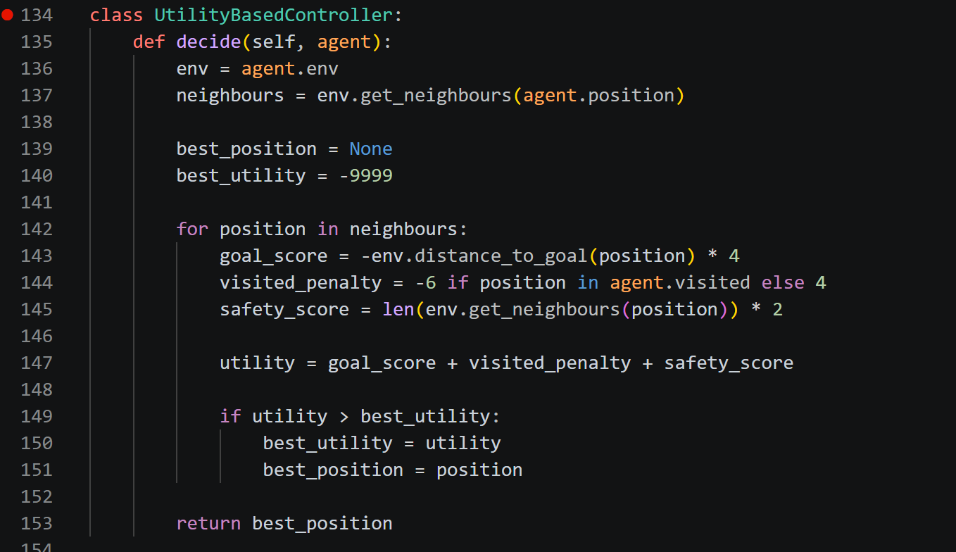
Figure 12 Utility Function Design for Action Evaluation
Each component contributes differently to the final decision-making process.

Goal Score Evaluation
The primary objective of the agent is to reach the goal location as efficiently as possible. To encourage goal-oriented behaviour, a goal score is calculated using the Manhattan distance between the neighboring position and the goal.

Figure 13 Goal Score Calculation within the Utility Function
The distance value is multiplied by -4 which means that positions closer to the goal produce higher utility values. As the distance decreases, the negative penalty becomes smaller which making those positions more attractive.
For example:
Position | Distance to Goal | Goal Score
A | 8 | -32
B | 5 | -20
C | 2 | -8

Position C would be preferred as it produces the highest utility contribution. This mechanism ensures that the agent continuously attempts to reduce the distance between itself and the destination. Without this component, the agent would have no incentive to move toward the goal and cloud wander randomly throughout the maze.

Visited Penalty Evaluation
A common problem in navigation systems is repeated movement between previously explored locations. This behavior can cause the agent to become trapped in loops and significantly reduce navigation efficiency. To prevent this issue, a visited penalty is introduced.

Figure 14 Visited Location Penalty Calculation
If a neighboring position has already been visited, the controller assigns a penalty of -6. Conversely, unvisited positions receive a reward of +4. This design encourages exploration and reduces repetitive movement patterns.
For example:
Position | Previously Visited | Utility Contribution
A | Yes | -6
B | No | +4

The controller naturally prefers Position B because it promotes exploration. This component is particularly important in maze environments where dead ends and loops frequently occur.

Safety Score Evaluation
While moving toward the goal is important, selecting a path that immediately leads into a dead end can negatively impact navigation performance. To address this issue, a safety score is included in the utility function.

Figure 15 Safety Score Calculation Based on Available Neighbours
The safety score evaluates the number of valid neighboring cells available from a candidate position. The position that offers more future movement options receive higher utility values.
For example:
Position | Available Neighbors | Safety Score
A | 1 | 2
B | 3 | 6
C | 4 | 8

Position C is considered safer as it provides greater flexibility for future navigation decisions. This mechanism helps the agent narrow pathways and dead ends whenever possible.

Action Selection Process
After calculating utility values for all neighboring positions, the controller compares the results and identifies the highest-scoring action. The selection process is implemented as following below.

Figure 16 Utility-Based Action Selection Process
The variable “best_utility” stores the highest utility value encountered during evaluation while “best_position” stores the corresponding position. Once all neighboring positions have been evaluated, the controller returns the position with the highest utility score. This process guarantees that every movement decision is based on a quantitative assessment of environmental conditions.

Utility-Based Behavior Analysis
The Utility-Based System demonstrated the highest level of adaptability among the three AI architectures implemented in this project. Unlike FSM which relies on predefined states or Behavior Trees which follow hierarchical decision rules, the Utility-Based System continuously recalculates utility values based on current environmental condition.
The controller simultaneously balances:
- Goal progression
- Obstacle avoidance
- Exploration
- Loop prevention
- Future movement flexibility
This allows the agent to respond intelligently to changing maze conditions without requiring predefined behavioral states or decision trees. As a result, the Utility-Based System is generally expected to achieve higher navigation efficiency and grater adaptability during performance evaluation. The architecture effectively satisfies the project requirement of selecting action based on their benefits and costs while prioritizing actions that maximize overall utility and minimize navigation risks.

Task 4: Simulate Scenario Environment

Overview of the Simulation Environment
The simulation environment serves as the operating space in which the intelligent agents perform navigation tasks. The environment was designed using a grid-based maze structure to simulate a realistic navigation problem where the agent must travel from a starting location to a goal destination while avoiding obstacles. Moreover, a maze environment was selected as it provides a controlled setting that allows the performance of different AI architectures to be compared under identical conditions. By using the same maze structure for all controllers, any differences in performance can be attributed to the decision-making architecture rather than environmental variations.
The maze is represented using a two-dimensional Gird where each character corresponds to a specific object within the environment.

Figure 17 Maze Structure Used for the Navigation Environment
Within the maze:
- S represents the starting position
- G represents the goal position
- # represents walls or obstacles
- . represents valid paths
This layout creates multiple route, dead ends and constrained areas that require the agent to make intelligent navigation decisions.

Maze Environment Class
The simulation environment is managed through the “MazeEnvironment” class.
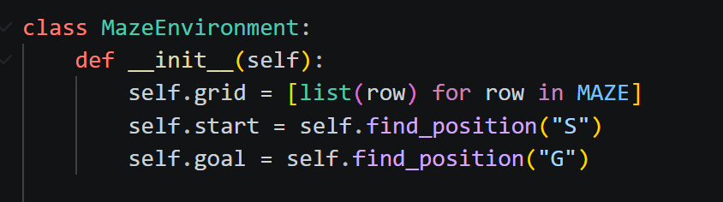
Figure 18 MazeEnvironment Class Implementation
When the environment is initialized, the maze is converted into a two-dimensional list structure to allow individual cells to be accessed efficiently. Moreover, the constructor also identifies the coordinates of both the starting position and goal position. These locations are stored and later used by the controllers to calculate navigation paths. This design allows the environment to be recreated easily during simulation runs which ensuring that all controllers are evaluated under identical conditions.

Locating the Start and Goal Positions
The “find_position()” function searches through the maze to identify the coordinates of a specified symbol.
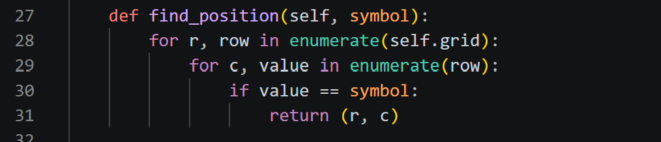
Figure 19 Start and Goal Position Detection Function
This function is used to locate both the starting position (S) and goal position (G). By dynamically searching the maze instead of hardcoding coordinates, the environment becomes more flexible. Future maze layouts can be modified without changing the navigation algorithms.

Movement Validation
One of the most important responsibilities of the environment is preventing the agent from moving through walls. This is handled by the “is_valid()” function.

Figure 20 Movement Validation Function
Whenever a controller proposes a movement, the environment checks whether the destination cell contains a wall. If the destination contains a wall (#), the movement is rejected. This validation mechanism ensures that:
- The agent remains within valid paths
- Obstacles function correctly
- Navigation results remain realistic
Without this validation process, the agent could move through walls and bypass the maze entirely which making the evaluation meaningless.

Neighbor detection
The environment must also determine which movements are available at any given position. This functionality is implemented through the “get_neighbours()” function.
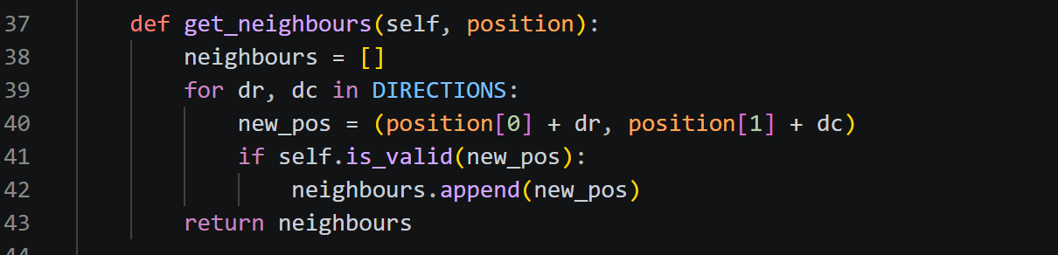
Figure 21 Neighbour Detection Function
The function examines all four movement directions:
- Up
- Down
- Left
- Right
Only positions that pass the validity check are added to the neighbor list. This information is essential because all three AI architectures rely on neighboring positions when making navigation decisions.

Goal Distance Calculation
To support intelligent navigation, the environment provides a distance estimation function.
Figure 22 Goal Distance Calculation Using Manhattan Distance
This function calculates the Manhattan Distance between the current position and the goal. Moreover, the distance value provides a numerical estimate of how close the agent is to the destination.
All three AI controllers utilize this information:
- FSM uses it to trigger the Reaching Goal state
- Behaviour Tree uses it to evaluate the Goal Near condition
- Utility-Based System uses it as part of the utility calculation
This demonstrates how a shared environmental feature can support multiple AI architectures.

Task 5: Agent Behaviour

Agent Architecture
The agent acts as the autonomous entity responsible for navigating the maze. Furthermore, the agent is implemented using the “Agent” class.
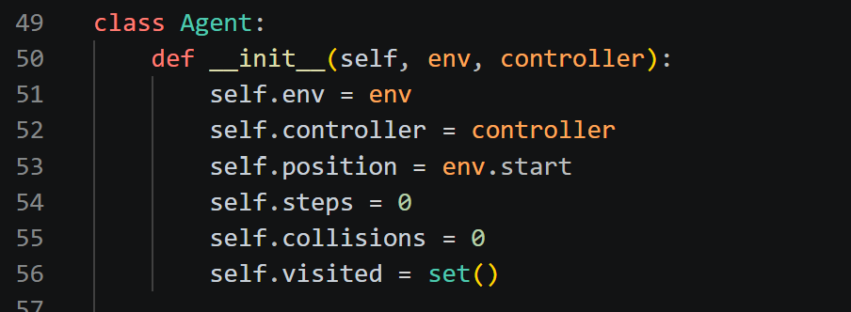
Figure 23 Agent Class Implementation
The agent maintains several important pieces of information:
- Current position
- Assigned controller
- Number of steps taken
- Collision count
- Previously visited locations
These variables allow the agent to track its progress throughput navigation

Controller-Based Decision Making
A key feature of the system is that the agent itself does not contain ant navigation logic. Instead, decision-making is delegated to the selected AI controller.
Figure 24 Controller-Based Decision-Making Mechanism
This design creates a clear separation between:
- Environment
- Agent
- Decision-making architecture
As a result, the same agent can be controlled by FSM, Behavior Tree or Utility-Based System without modifying the navigation and code reusability.

Movement Execution
Once a controller selects a movement, the agent attempts to move to the chosen position.
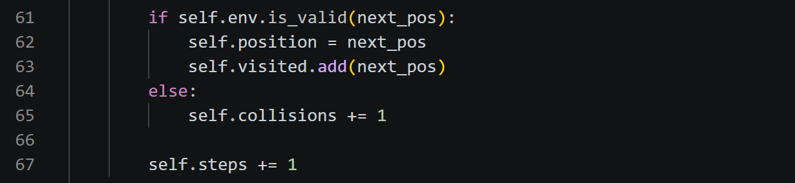
Figure 25 Agent Movement Execution Process
If the destination is valid, the agent moves successfully and records the location as visited. If the movement is invalid, the collision counter increases. Moreover, tracking collisions provides useful information for evaluating obstacle avoidance performance during simulations.

Goal Detection
The navigation process continues until the goal position is reached.

Figure 26 Goal Detection Function
This simple condition allows the simulation to determine whether the navigation task has been completed successfully. Goal detection is used throughout both demonstration runs and performance evaluation simulations.

Navigation Loop
The complete navigation cycle is executed through the following loop:

Figure 27 Main Navigation Loop Execution

During each iteration:
- The controller evaluates the environment.
- A movement decision is generated.
- The environment validates the movement.
- The agent updates its position.
- Progress towards the goal is reassessed.
This cycle continues until the agent reaches the destination or exceeds the maximum allowed number of steps.

Obstacle Avoidance Behavior
Obstacle avoidance is essential to ensure that the agent can navigate the maze without colliding with walls or becoming trapped. In this project, the environment validates every movement to prevent the agent from entering invalid positions. Each AI architecture uses a different strategy for avoiding obstacles. The Finite State Machine enters the Avoiding Obstacle state when movement options become limited while the Behaviour Tree activates obstacle avoidance when obstacle-related conditions are detected. Meanwhile, the Utility-Based System incorporates safety into its utility calculation by favouring positions with more available movement options. Although implemented differently, all three controllers effectively support obstacle avoidance and contribute to successful navigation.

Adaptability Analysis
Adaptability refers to the ability of the agent to adjust its behaviour according to environmental conditions. In this project, each AI architecture demonstrates adaptability through a different decision-making approach. The Finite State Machine adapts through state transitions which allowing the agent to switch between exploring, obstacle avoidance and goal-reaching behaviours. Moreover, the Behaviour Tree adapts by continuously evaluating conditions and selecting the most appropriate action. Furthermore, the Utility-Based System adapts by recalculating utility values at every decision point and choosing the action with the highest benefit. These mechanisms enable the agent to respond to changes in the maze environment while maintaining progress towards the goal.

The Final Output Result
The output of Finite State Machine:
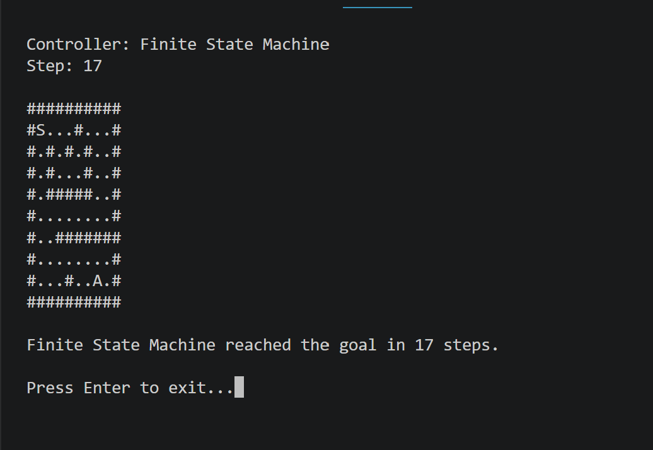
Figure 28 FSM Agent Navigating Through the Maze Environment
The output of the Behaviour Tree:
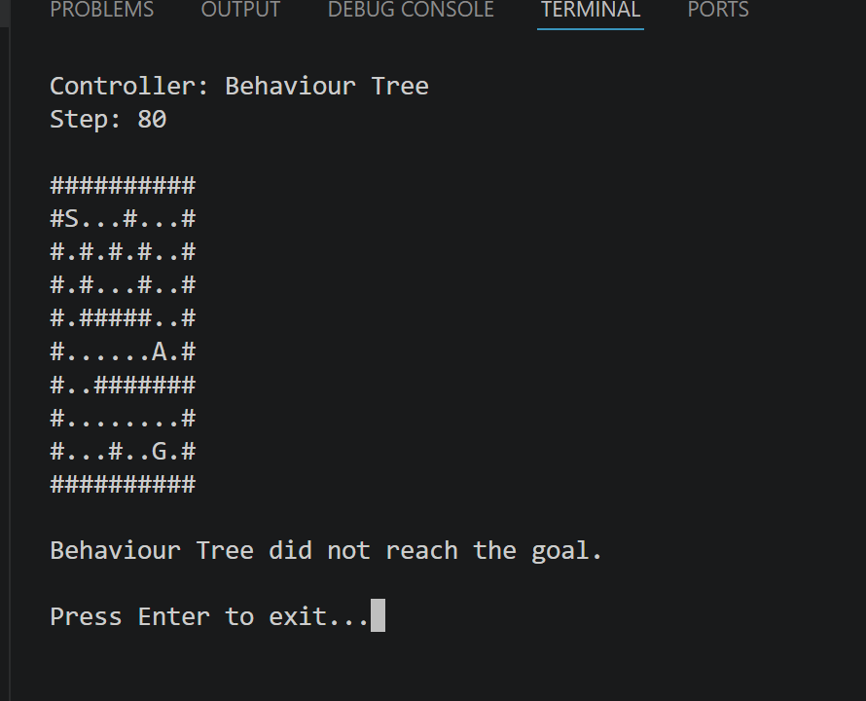
Figure 29 Behaviour Tree Agent Navigating Through the Maze Environment
The output of the Utility-Based System:
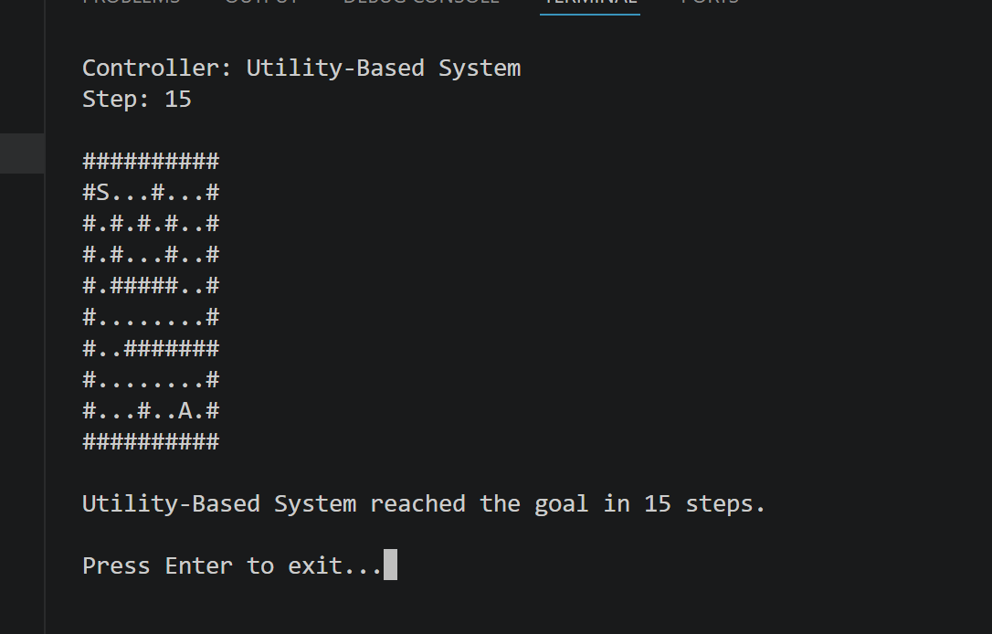
Figure 30 Utility-Based Agent Navigating Through the Maze Environment

The output of Performance Evaluation Results:
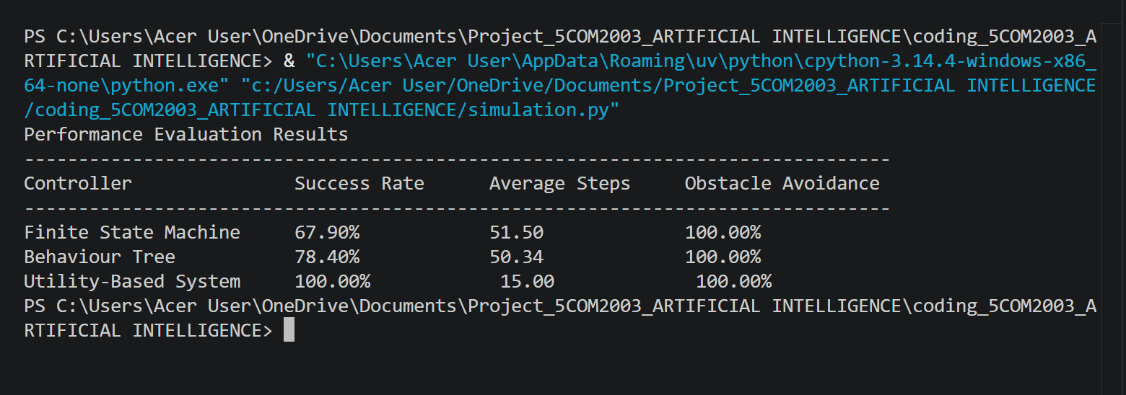
Figure 31 Performance Comparison of FSM, Behaviour Tree, and Utility-Based System Controllers

Comparative Analysis
The performance evaluation shows that each AI architecture uses a different decision-making approach, resulting in differences in navigation efficiency, obstacle avoidance and adaptability. Although all three controllers operate within the same maze environment and share the same objective of reaching the goal, their internal logic influences how the agent behaves throughout the navigation process.
The Finite State Machine (FSM) controller relies on predefined states and transitions to guide the agent. The agent switches between Exploring, Avoiding Obstacle and Reaching Goal states depending on the surrounding environment. This approach makes the controller simple and easy to understand as each state has a clearly defined purpose. However, the FSM is less flexible because its behaviour is limited to the states and transitions defined during implementation. As a result, the agent may not always choose the most efficient path when facing more complex situations.
The Behaviour Tree controller uses a hierarchical structure consisting of conditions and actions. Instead of changing states, the controller continuously evaluates conditions and executes the highest-priority behaviour. This allows the agent to react more effectively to environmental changes and provides better organization of behaviours. The modular structure also makes the controller easier to extend and maintain compared to the FSM.
The Utility-Based System takes a different approach by evaluating all possible actions and assigning a utility value to each option. The decision is based on factors such as distance to the goal, previously visited locations and movement safety. By selecting the action with the highest utility score, the agent can make more informed decisions and balance multiple objectives simultaneously. This generally results in better adaptability and navigation efficiency.
When comparing the performance metrics, the Success Rate indicates how consistently the agent reaches the goal while Average Steps measures the efficiency of the chosen path. The Obstacle Avoidance Rate reflects how effectively the controller prevents collisions and navigates around walls. Controllers with higher success rates and lower average steps are considered more effective because they reach the goal more reliably and efficiently.
Overall, the Utility-Based System is expected to produce the strongest performance due to its ability to evaluate multiple factors before making a decision. The Behaviour Tree provides a good balance between flexibility and structured decision-making while the FSM offers a simple and reliable solution but with lower adaptability. Despite their differences, all three architectures successfully demonstrate autonomous decision-making and contribute to effective maze navigation.

Conclusion
This project successfully implemented and compared three AI decision-making architectures for maze navigation. The Finite State Machine used predefined states to control behaviour, the Behaviour Tree employed hierarchical condition-based logic and the Utility-Based System used utility calculations to select actions dynamically. The results demonstrate that different AI architectures produce different navigation behaviours and performance outcomes. While FSM provides simplicity and Behaviour Trees offer modularity, the Utility-Based System generally exhibits the highest adaptability due to its ability to evaluate multiple environmental factors simultaneously. Overall, the project successfully achieved its objective of evaluating different AI architectures for autonomous decision-making within a maze navigation environment.

References
Colledanchise, M., & Ogren, P. (2017). How Behavior Trees Modularize Hybrid Control Systems and Generalize Sequential Behavior Compositions, the Subsumption Architecture, and Decision Trees. IEEE Transactions on Robotics, 33(2), 372–389. https://doi.org/10.1109/tro.2016.2633567

Kaelbling, L. P., Littman, M. L., & Cassandra, A. R. (1998). Planning and acting in partially observable stochastic domains. Artificial Intelligence, 101(1-2), 99–134. https://doi.org/10.1016/s0004-3702(98)00023-x

